Screenshot of df –h:

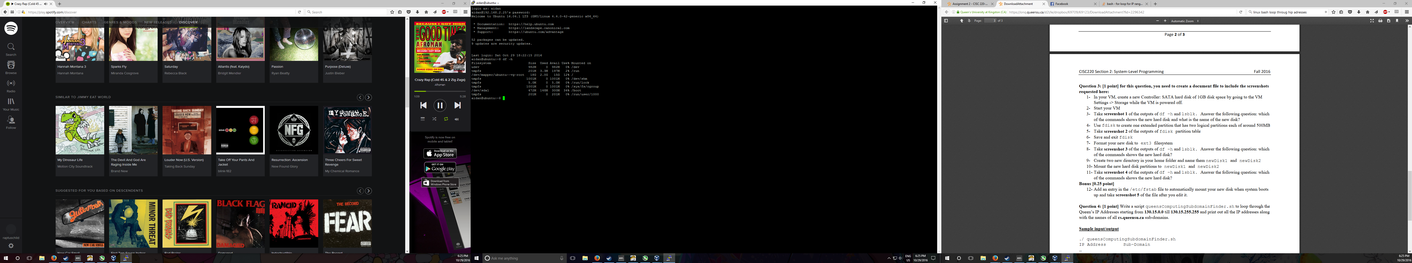

Output of lsblk:

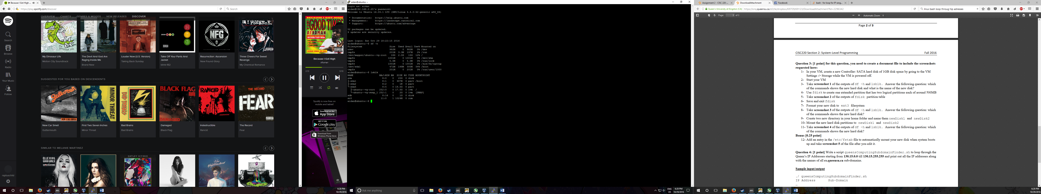

The command that shows the new hard disk is lsblk. The name of the disk is sdb.

Screenshot of the disk partition table:

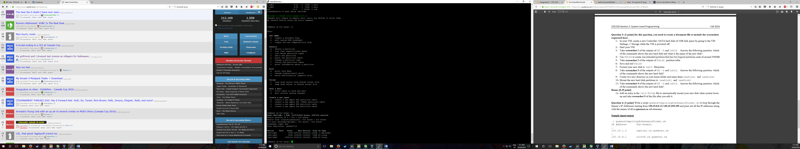

Formatted partition using the command: **sudo /sbin/mkfs -t ext3 /dev/sdb5** and the command **sudo /sbin/mkfs -t ext3 /dev/sdb6**

A screenshot of both lsblk and df –h commands:

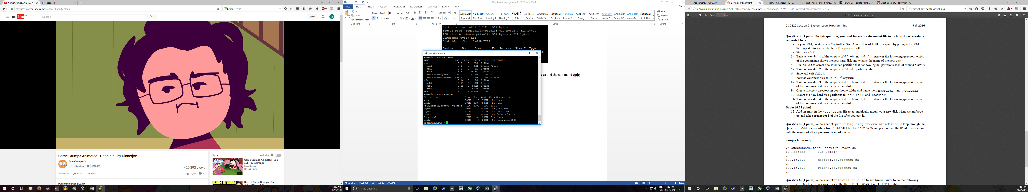

The command lsblk shows the hard disk sdb

After mounting the hard disk partitions to the specified folders

The output of df –h command

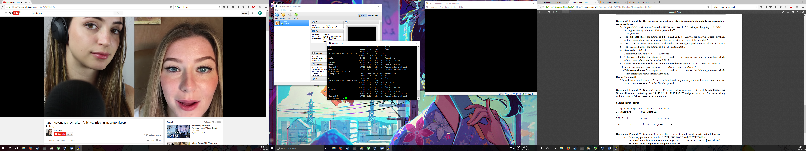

The output of the lsblk command:

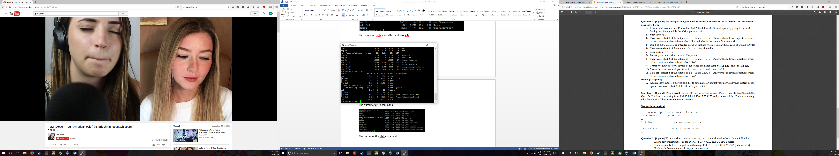

Both of the commands now show the new hard disk partions